**FPD LINK**

**Cable/Connector Assembly Specification**

**00.06.01.005**



# Change Control

|  |  |  |  |
| --- | --- | --- | --- |
| **Version** | **Date** | **Author CDSID** | **Changes / Remark** |
| AA | 6/19/2018 | hkadry | Initial Release |
| AB | 3/1/19 | hkadry | 1. Added tables for approved connector and cable combinations 2. Updated signal integrity limit for FPD LINK III and added for FPD LINK IV 3. Added Appendix for assembly signal integrity approval process. |
|  |  |  |  |

**Note:**

*This document was written by the Research and Advanced Electrical Architecture Netcom Group. For question please contact:*

*Haysam Kadry (hkadry)*

*Research Engineer*

[*hkadry@ford.com*](mailto:hkadry@ford.com)

*313-600-4193*

Table of Contents

1. Introduction 5

1.1 Scope 5

1.2 Reference documents 5

1.3 Definitions, Abbreviations and Acronyms 5

1.3.1 Abbreviations and Acronyms 5

1.3.2 Definitions 5

2. Approved Connector and Cable Combinations 6

3. Cable/Connector Assembly Limit Lines 7

3.1 Return Loss (sdd11, sdd22, s11, s22) 7

3.1.1 FPD LINK III 7

3.1.2 FPD LINK IV 8

3.2 Insertion Loss (sdd12, sdd21, s12, s21) 8

3.2.1 FPD LINK III 8

3.2.2 FPD LINK IV 9

4. Cable/Connector Assembly PPAP 10

4.1 PPAP 10

4.2 Production Phase End of Line Testing 10

5. Appendices 11

5.1 Appendix A (General Cable/Connector Assembly Information) 11

5.1.1 Maximum Cable Length (All cable segments with Inlines) 11

5.1.2 Minimum Segment Length 11

5.1.3 Cable Connectors (Mating Connector/Inline Connector) 11

5.2 Appendix B (Cable-Connector Assembly Signal Integrity Approval Process) 12

5.2.1 Assembly Construction (Cable/Connector) Required for Approval Process 12

5.2.1.1 Assembly to Test Worst Case Insertion Loss 12

5.2.1.2 Assembly to Test Worst Case Return Loss 12

5.2.1.3 Reference Cables to Show Inline Performance 12

5.2.1.4 Assembly Approval Flow Chart 13

5.2.1.4.1 Determining Shortest Assembly Segment 13

5.2.1.4.2 Determining Maximum Assembly Length 14

5.2.1.4.3 Final Assembly Construction 15

5.2.2 Method 1: Physical Measurements for Cable Assembly Constructions 15

5.2.3 Method 2: Simulation Measurements for Cable/Connector Assembly Construction 16

5.3 Appendix C (Measurement Setup) 17

List of Tables

Table 1.1: Reference Documents 5

Table 1.2: Abbreviations and Acronyms 5

Table 1.3: Definitions 5

Table 2.1 Approved FAKRA/Cable Combinations 6

Table 2.1 Approved Mini Coax/Cable Combinations 6

Table 2.1 Approved HSD/Cable Combinations 6

Table 5.1: Assembly Construction Configurations 15

Table 5.2: Cable/Connector Sub Segment Lengths 16

Table 5.3: Assembly Simulation Configuration 16

List of Figures

Figure 3.1 FPD LINK III Cable/Connector Assembly Return Loss Limit 7

Figure 3.2 FPD LINK IV Cable/Connector Assembly Return Loss Limit 8

Figure 3.3 FPD LINK III Cable/Connector Assembly Insertion Loss Limit 8

Figure 3.4 FPD LINK IV Cable/Connector Assembly Insertion Loss Limit 9

Figure 5.1: 15 meters, 4-inline Connectors (Equally Spaced) 12

Figure 5.2: 1 meter, 4-inline Connectors (Equally Spaced) 12

Figure 5.3: 15 meters, 0-Inline Connectors 12

Figure 5.4: 1 meters, 0-Inline Connectors 12

Figure 5.5: Shortest Segment Flow Chart 13

Figure 5.6: Maximum Assembly Length Flow Chart 14

Figure 5.7: Final Assembly Construction 15

# Introduction

## Scope

High speed protocols require well engineered channel mediums for robust operations. An end to end channel consists of the PCB board traces and components, PCB header connector, cable mating connector, cable and cable inline connectors. These sections of the channel will need to be engineered to interface and work together.

This Specification will mainly focus on the connectors and cables portion of the communication channel. These cables and connectors are uniquely designed to be impedance controlled and balanced, so when placed in a channel meet the S-Parameter requirements for insertion, and return loss, mode conversion, and cross talk.

## Reference documents

|  |  |  |  |
| --- | --- | --- | --- |
|  | Document Number | File Name/Reference | Version |
| **1** | 00.06.03.004 | FPD LINK Physical Layer Specification | AB |
| **2** | 00.06.01.306 | FPD Link Cable/Connector Assembly  Design Verification Checklist | AB |
|  |  |  |  |

Table 1.1: Reference Documents

## Definitions, Abbreviations and Acronyms

### Abbreviations and Acronyms

|  |  |
| --- | --- |
| COAX | Coaxial |
| FMC | Ford Motor Company |
| JUTP | Jacketed Unshielded Twisted Pair |
| PCB | Printed Circuit Board |
| QTP | Quad Twisted Pair |
| SPP | Shielded Parallel Pair |
| STP | Shielded Twisted Pair |
| TDR | Time Domain Reflectometer |
| UTP | Unshielded Twisted Pair |
| VNA | Vector Network Analyzer |

Table 1.2: Abbreviations and Acronyms

### Definitions

|  |  |
| --- | --- |
| Assembly | An assembly is cable that terminated with mating connector on both ends. |
| Bus | A bus is a collection of one or more wires connecting two or more nodes. Each electronic device is equipped with a specific, standardized electronic interface in order to guarantee compatibility between exchanged binary items of information |
| Characteristic Impedance | The impedance along a transmission line, as a result of wave voltage to current ratio |
| Differential signalling | This is a method used to transmit data using two complimentary signals. |
| Impedance Discontinuity | The impedance mismatch at a junction in an impedance controlled system |
| Insertion Loss | This defines the amount of signal lost during the journey of a signal from point A to point B. |
| Mode Conversion | This is due to the imbalance in a differential pair (common to differential and vice versa) |
| Return Loss | This defines the amount of signal reflected back to the source after encountering an impedance mismatch in the medium. Return loss can contribute to insertion loss if significant |
| S-Parameters | Scattering Parameters, describe the electrical behavior of linear electrical networks when stimulated by various electrical signals. The data is represented by (Return Loss, Insertion Loss, Mode Conversion, etc.) |

Table 1.3: Definitions

# Approved Connector and Cable Combinations

CCA_FPDLINK_02_001

To approve any new connector and cable combinations you will need to contact both the Ford connector and cable groups.

CCA_FPDLINK_02_002

Assemblies must be constructed from the approved parts (see tables below) and must meet the signal integrity limit lines in section 3.

Check with module DNR Engineer for connection interface. The approved interface parts are located in ref[7]

FAKRA Connector:

|  |  |  |  |  |
| --- | --- | --- | --- | --- |
| Connector/Inline | Connector/Inline Supplier | Cable | Cable Supplier | Comments |
|  |  |  |  |  |
| Rosenberger | Rosenberger | Dacar 462 | Leoni | Note that, these combinations are valid only for FPD Link III protocol.  Moving forward, all the new designs should use the Mini Fakra / Mini Coax connectors |
| Dacar 462-2 | Leoni |
| Dacar 302-3 | Leoni |
| RTK031 | G&G |
| Tyco (TE) | Tyco (TE) | Dacar 462 | Leoni |
| Dacar 462-2 | Leoni |
| Dacar 302-3 | Leoni |
| RTK031 | Condumex |
| Molex | Molex | Dacar462 | Leoni |
| Delphi / Aptiv | Delphi / Aptiv | Dacar 462-2 | Leoni |
| Dacar 302-3 | Leoni |

Table 2.1 Approved FAKRA/Cable Combinations

Mini FAKRA / MATEnet (Mini Coax)

|  |  |  |  |  |
| --- | --- | --- | --- | --- |
| Connector/Inline | Connector/Inline Supplier | Cable | Cable Supplier | Comments |
|  |  |  |  |  |
| Rosenberger | Rosenberger | Dacar 462 | Leoni | These combinations are applicable to FPD Link III and FPD Link IV protocols |
| Dacar 462-2 | Leoni |
| Dacar 302-3 | Leoni |
| RTK031 | G&G |
| RTK044 | G&G |
| Tyco (TE) | Tyco (TE) | RTK031 | Condumex |

Table 2.1 Approved Mini Coax/Cable Combinations

HSD Connector

|  |  |  |  |  |
| --- | --- | --- | --- | --- |
| Connector/Inline | Connector/Inline Supplier | Cable | Cable Supplier | Comments |
|  |  |  |  |  |
| Rosenberger | Rosenberger | Dacar 535 | Leoni | HSD Connector are good only up to 2.0 GHz. Thus these combination are only good for FPD LINK III |
| Tyco | Tyco (TE) | Dacar 535 | Leoni |
| Mitsumi | Mitsumi | Dacar 535 | Leoni |

Table 2.1 Approved HSD/Cable Combinations

# Cable/Connector Assembly Limit Lines

Different applications will require different assembly configurations. It is the supplier’s responsibility to demonstrate that the assembly configuration is compliant with Ford’s assembly limit lines. The cable/connector assembly shall be tested with the correct rise time of the signal being sent over the cable (*faster rise times can be used for an in-depth analysis but may lead to false failures*). The test setup shall be conducted in accordance to the specification in ref [3] and ref [4].

## Return Loss (sdd11, sdd22, s11, s22)

CCA_FPDLINK_03_001

### FPD LINK III

$$RL≤\left\{\begin{aligned}-24 dB, &0 MHz≤f≤100 MHz \\ -14+10\log_{10}{(f(GHz)}) dB, &100MHz<f≤1GHz \\ -14 dB, &1GHz<f≤2.5GHz\end{aligned}\right.$$

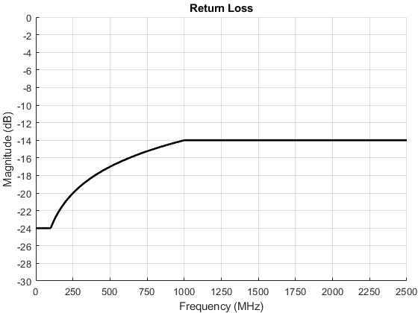

PASS

FAIL

Figure 3.1 FPD LINK III Cable/Connector Assembly Return Loss Limit

### FPD LINK IV

$$RL≤\left\{\begin{aligned}-24 dB, &0 MHz≤f≤200 MHz \\ -14+14.4\log_{10}{(f(GHz)}) dB, &200MHz<f≤1GHz \\ -14 dB, &1GHz<f≤4.25GHz\end{aligned}\right.$$

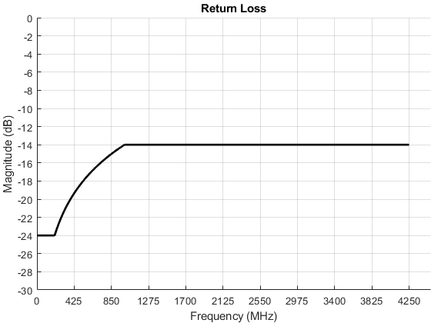

FAIL

PASS

Figure 3.2 FPD LINK IV Cable/Connector Assembly Return Loss Limit

## Insertion Loss (sdd12, sdd21, s12, s21)

CCA_FPDLINK_03_002

### FPD LINK III

$$IL≥\left\{-0.2-0.6*\sqrt{f\left(GHz\right)}-0.3*\sqrt{f\left(MHz\right)}-0.7*f\left(GHz\right)dB, 0.5MHz≤f≤2.5 GHz\right.$$

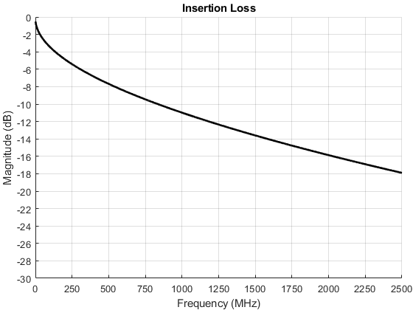

FAIL

PASS

Figure 3.3 FPD LINK III Cable/Connector Assembly Insertion Loss Limit

### FPD LINK IV

$$IL≥\left\{-0.2-0.6*\sqrt{f\left(GHz\right)}-0.3*\sqrt{f\left(MHz\right)}-0.7*f\left(GHz\right)dB, 0.5MHz≤f≤4.25 GHz\right.$$

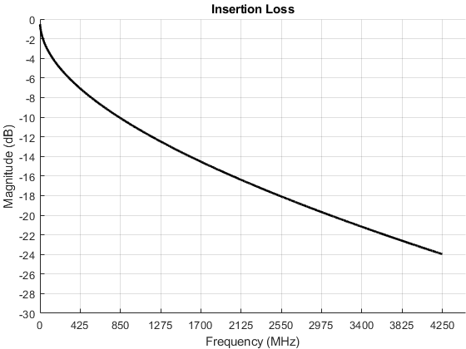

PASS

FAIL

Figure 3.4 FPD LINK IV Cable/Connector Assembly Insertion Loss Limit

# Cable/Connector Assembly PPAP

## PPAP

CCA_FPDLINK_04_001

The harness supplier shall ensure the production assembly meets the signal integrity requirements CCA_FPDLINK_003_xxx throughout the PPAP process. If the harness supplier is acquiring the assembly from another supplier, then the cable supplier will need to conduct all the PPAP tests and ensure the full assembly meets the limit lines presented in this specification.

The supplier must provide measured data showing compliance.

## Production Phase End of Line Testing

CCA_FPDLINK_04_002

Since production-process variation of the cable connector assembly may result in non-compliance with the signal integrity requirements in CCA_AE_003_xxx, statistical process control methods must be implemented in production. The parameter that must be verified in production is impedance: The differential impedance shall be 100Ω±10%

# Appendices

These appendices are general guidelines for cable construction and signal integrity approval process.

## Appendix A (General Cable/Connector Assembly Information)

### Maximum Cable Length (All cable segments with Inlines)

Based on the vehicle application, different cable lengths with a certain number of inlines are required. Based on the physics of the cable, each cable can achieve a max distance before failing the insertion loss requirement. Insertion loss is a parameter dependent mainly on cables loss/meter and return loss if the channel presents impedance mismatches. Longer distances will need to utilize cable(s) with lower insertion loss and tightly controlled impedance design.

The cable length is also dependent on the max operating frequency. Higher data rate protocols operate at higher frequencies limiting the length of the cable. Higher frequency operation necessitates shorter cable length.

Both factors should be considered when choosing the cable required for the chosen protocol.

### Minimum Segment Length

In a cable assembly, adding inlines introduces different segment lengths and impedance mismatches. These two variables will effect both insertion and return loss. Return loss is more critical when adding inlines.

Inlines introduce impedance mismatches. These impedance mismatches can be controlled with a good connector design. A tightly controlled connector impedance will lead to less return loss and will minimally effect the signal quality due to less signal being reflected.

Placing a short cable segment at the transmitter/receiver with an impedance mismatch will cause the reflected signal/echoes to strike the transmitter/receiver corrupting newly transmitted data or making it difficult for the receiver to detect data.

It is critical to know the system, and to select the correct cable/connector assembly to ensure signal quality and link robustness. If shorter segments are needed closer to the transmitter or receiver, then it is important to choose an assembly with inlines having a tightly controlled impedance.

### Cable Connectors (Mating Connector/Inline Connector)

Since the connectors and cables will be evaluated as an assembly, ensure the selected connector’s characteristics match up well with the selected cable. Connectors and inlines should not introduce impedance mismatch outside the overall assembly characteristic impedance tolerance.

Things to look for

* How well cable twists at connector and inlines are managed.
* Any discontinuities in the shield

## **Appendix B (Cable-Connector Assembly Signal Integrity Approval Process)**

### Assembly Construction (Cable/Connector) Required for Approval Process

For signal integrity electrical qualification, the following set of cable-connector assembly samples are required. These assembly configurations will need to be acquired from a connector or cable supplier who has paired up with a counterpart to build full assemblies for Ford. These assemblies must be built using approved cables (approved by the EDS group) and approved connectors (approved by the connector group). These cables must be built with production intent tooling and not prototype or hand built samples.

***Note: Cable configuration along with connector gender are shown below for easy understanding (F – Female, M – Male)***

#### Assembly to Test Worst Case Insertion Loss

Based on production input, the maximum lengths seen in the vehicle range to 15 meters with four inlines. Some assemblies might be longer or might have more inlines, however, this is a good common representation for the maximum length and interconnects and will be used as a bench mark to determine worst case insertion loss. The 3m distance between the interconnects is to minimize the effect of return loss on the insertion loss measurement.



Figure 5.1: 15 meters, 4-inline Connectors (Equally Spaced)

#### Assembly to Test Worst Case Return Loss

Based on production input, the minimum lengths seen in the vehicle are about 0.2m. Some assemblies might be shorter however; this is a good common representation for a shortest segment and will be used as a benchmark to determine worst-case return loss. The 1m length is to minimize the effect of insertion loss on the return loss measurement.



Figure 5.2: 1 meter, 4-inline Connectors (Equally Spaced)

#### Reference Cables to Show Inline Performance

These two cable configuration will be used to evaluate the interconnect performance from the cables above.



Figure 5.3: 15 meters, 0-Inline Connectors



Figure 5.4: 1 meters, 0-Inline Connectors

#### Assembly Approval Flow Chart

The flow charts below will show the process flow required to approve new connector and cable assemblies for signal integrity performance.

##### Determining Shortest Assembly Segment

This flow chart will determine the allowable shortest segment between two interconnects in an assembly.



Figure 5.5: Shortest Segment Flow Chart

##### Determining Maximum Assembly Length

This flow chart will determine the maximum assembly that can be constructed using the same cable to meet the signal integrity limit lines in section 3. This process does not incorporate the mixing of multiple cable types. Any mixing will require separate qualification and then testing the mixing of two cables.

Regardless of this outcome, any full cable assembly must meet the signal integrity requirements in section 3.



Figure 5.6: Maximum Assembly Length Flow Chart

##### Final Assembly Construction



Figure 5.7: Final Assembly Construction

### Method 1: Physical Measurements for Cable Assembly Constructions

Physically construct and measure cable/connector assemblies using the combination in the table below and stepping through the approval flow charts for shortest and maximum assembly length.

|  |  |  |  |
| --- | --- | --- | --- |
|  | Cable Configuration | Cable Length Split (m) | Connector Gender(1) |
| 1 | 15 m, 4-inlines | 3+3+3+3+3 | F----F-M----F-M----F-M----F-M----F |
| 2 | 13 m, 4-inlines | 1+3+3+3+3 | F----F-M----F-M----F-M----F-M----F |
| 3 | 12 m, 3-inlines | 3+3+3+3 | F----F-M----F-M----F-M----F |
| 4 | 10 m, 3-inlines | 1+3+3+3 | F----F-M----F-M----F-M----F |
| 5 | 9.2 m, 3-inlines | 0.2+3+3+3 | F----F-M----F-M----F-M----F |
| 5 | 9 m, 2-inlines | 3+3+3 | F----F-M----F-M----F |
| 6 | 7 m, 2-inlines | 1+3+3 | F----F-M----F-M----F |
| 7 | 6.2 m, 2-inlines | 0.2+3+3 | F----F-M----F-M----F |
| 8 | 6 m, 1-inlines | 3+3 | F----F-M----F |
| 9 | 1 m, 4-inline | 0.2+0.2+0.2+0.2+0.2 | F----F-M----F-M----F-M----F-M----F |

Table 5.1: Assembly Construction Configurations

1. *F denotes female and M denotes male*

### Method 2: Simulation Measurements for Cable/Connector Assembly Construction

Physically construct and measure the following sub segments to create a database. This step can be done by the cable/connector assembler and shall be done at all required temperatures.

Full assemblies can be constructed by cascading the physical measurement data of the cable sub segments using simulation tool. The overall assembly shall meet the signal integrity limit lines in section 3.

|  |  |  |  |  |
| --- | --- | --- | --- | --- |
|  | Sub Segment Length (m) | Connector Gender | Touchtone File | Comments |
| 1 | 0.2 | F----F | File1 |  |
| 2 | 0.5 | F----F | File2 |  |
| 3 | 1~9 | F----F | File3 | Need 9 cable sections ranging from 1m to 9m |

Table 5.2: Cable/Connector Sub Segment Lengths

***Note: Make sure to de-embed the interface board (also known as Breakout Board) while measuring the individual cables that will further be cascaded along with other cables. This is to ensure the interface board artifacts are not duplicated multiple times during the cascading process*.**

To qualify cable/connector assembly using simulation process, you must follow the approval flow charts using the measured touchtone data of the following sub segment lengths (0.2m,1m,3m) at all required temperatures. These sub segments will allow the construction of the assembly configurations below the final assembly must meet the signal integrity requirements in section 3.

|  |  |  |  |
| --- | --- | --- | --- |
|  | Assembly Configuration | Cable Length Split (m) | Cascading Process(1)  (Touchstone Files) |
| 1 | 15 m, 4-inlines | 3+3+3+3+3 | File3-File3-File3-File3-File3 |
| 2 | 13 m, 4-inlines | 1+3+3+3+3 | File2-File3-File3-File3-File3 |
| 3 | 12 m, 3-inlines | 3+3+3+3 | File3-File3-File3-File3 |
| 4 | 10 m, 3-inlines | 1+3+3+3 | File2-File3-File3-File3 |
| 5 | 9.2 m, 3-inlines | 0.2+3+3+3 | File1-File3-File3-File3 |
| 5 | 9 m, 2-inlines | 3+3+3 | File3-File3-File3 |
| 6 | 7 m, 2-inlines | 1+3+3 | File2-File3-File3 |
| 7 | 6.2 m, 2-inlines | 0.2+3+3 | File1-File3-File3 |
| 8 | 6 m, 1-inlines | 3+3 | File3-File3 |
| 9 | 1 m, 4-inline | 0.2+0.2+0.2+0.2+0.2 | File1-File1-File1-File1-File1 |

Table 5.3: Assembly Simulation Configuration

1. File 1, 2 , 3 denotes the order the segments are place from port 1 to port 2

## Appendix C (Measurement Setup)

|  |  |
| --- | --- |
| **Parameter** | **Value** |
| Fstart | ≤300khz |
| Fstop | 9GHz |
| Sweep Type | Logarithmic |
| Sweep Points | 2000 |
| Output power | -10dBm |
| Measurement bandwidth | ≤500Hz |
| Port reference Impedance(Single Ended) | 50Ω |
| Port reference Impedance (Differential Mode) | 100Ω |
| Port reference Impedance (Common Mode) | 25Ω connector and board measurements and 200Ω for all other measurements |
| Data calibration kit | Use E-Cal or kit for calibration |
| Averaging Function | Not mandatory but if used16 times |
| Smoothing Function | Deactivated |
| Differential Port 1 | Ports 1 and 3 |
| Differential Port 2 | Ports 2 and 4 |
| Rise Time(Impedance Measurements) | ≤65ps (Also based on protocol speed) |
| Touch Tone File | .s4p (single ended data)  .s2p(single ended data) |
| Data format | Real + Imaginary or Magnitude/Angle |